Reasonable Arrangement for beds in Ophthalmonogy

Abstract: The paper studies the models of reasonable arrangement for beds in Ophthalmology. Through the analysis of the current situation in a particular hospital, a basic evaluation system is built up to assess the priority rule of arrangement. Based on the statistics we have generated several models in attempt to get better arrangement, and tested the effectiveness of the models by simulations. An original evaluation system and several unique models are built in the paper.

Keywords: Monte Carlo Simulation; Modeling; Bed Arrangement

- Problems Analysis

- Related variables
Date, Illness type, Number of vacant bed, Waiting period (the period between the diagnosis and check-in), Treatment period (the period between check-in and check-out)

- Problem analysis
  - Evaluation system built up: we need to build up some evaluation rules so that we can evaluate the efficiency of the FCFS system as well as the newly-developed system.
  - Model construction: we need to construct models for several related variables as bases for simulation.
  - Simulation: according to the models we can simulate the real case in hospital with different priority rules for 100,000 times and then get some result.
  - Comparison: based on the evaluation system we can compare the effectiveness of system under different priority rules.
  - Suggestion: based on the result and our evaluation system we will give some suggestion to the hospital.

- Important Assumption

- There are 79 available beds in total when the hospital starts to operate.
- Only five types of eye illness are concerned: single-eye cataract, double-eye cataract, retina illness, glaucoma and eye injury.
- Cataract operation can only be arranged on Monday and Wednesday. For double-eye cataract patients, the first operation can only be arranged on Monday.
- The period during check-in and check-out for each type of illness follow a particular type of probability distribution.
- The daily incidence of each type of illness follows a particular type of probability distribution.
- Because of the sufficient conditions for ophthalmic surgery, patients will check in as long as there is vacant bed.
- If a patient chooses the hospital, he will be on the waiting list until there is vacant bed for him to check in according to the priority rule.
- An eye injury patient will be rejected immediately if there is no vacant bed.

- Relevant Terminologies

exppdf () – exponential distribution with parameter.
normpdf () – normal distribution with parameters.
poisspdf () – Poisson distribution with parameter.
pdf – basic probability distribution.
T_{c} = curing period = after diagnose and before check-out
T_{i} = in-hospital period = after check-in and before check-out
T_{t} = treatment period = surgery period till check
T_{w} = waiting period = after diagnose and before surgery
T_{c} = T_{t}+T_{w}.

- Modeling and Simulation

- Model I: We try to find valid models - some probability distribution - for the daily incidence of each type of illness, according to the given three groups of data.

We have the hypothesis that the daily incidence of each type of illness follows a normal distribution or Poisson distribution. Using the statistics from the given data, we can plot the given data and standard distributions with corresponding variables, namely, the mean and variance for normal distribution, the mean for Poisson distribution. Then we calculate the mean square root of the difference between the given data and the distribution to see the validity of the modeling.

Here we show two examples of modeling process; one is for daily incidence of double-eye cataract and the other for retina. Through least square method, we can easily see that they follow Poisson distribution (See Figure 1 & Figure 2). And so do the other types of illness. Therefore we will use Poisson distribution random number generator to generate the daily incidence of each type of illness.

Figure 1 Daily Incidence Modeling of Double-eye Cataract
Sheet 1 Statistics for the Daily Incidence of Double-eye Cataract
Number of patients | Frequency | 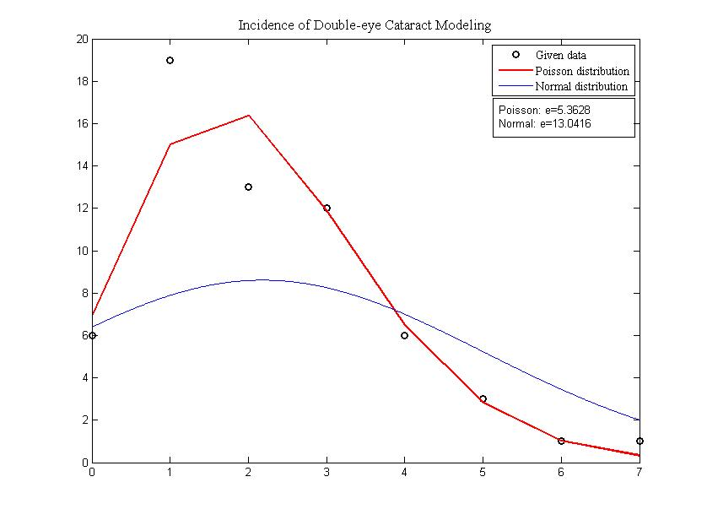
0 | 6
1 | 19
2 | 13
3 | 12
4 | 6
5 | 3
6 | 1
7 | 1
Figure 2 Daily Incidence Modeling of Retina
Sheet 2 Statistics for the Daily Incidence of Retina
Number of patients | Frequency | 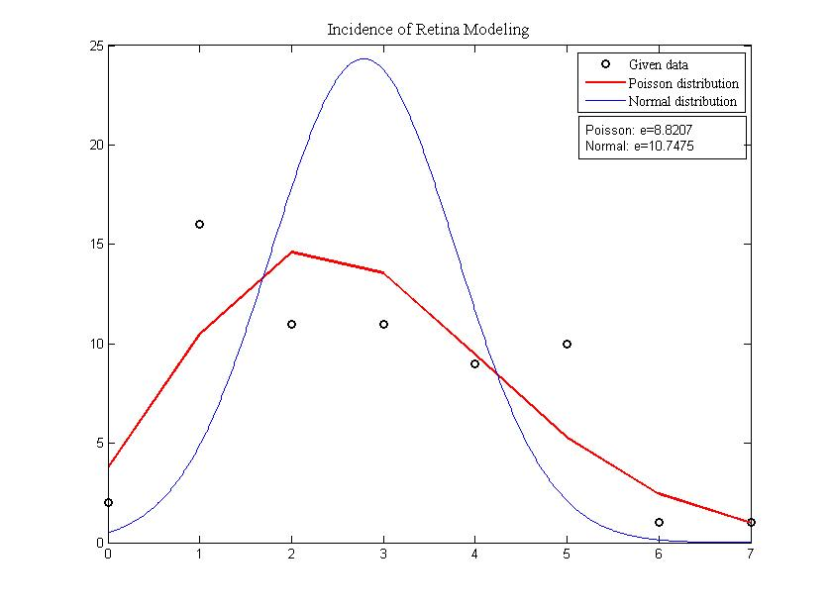
0 | 2
1 | 16
2 | 11
3 | 11
4 | 9
5 | 10
6 | 1
7 | 1

- Model II: We try to find valid models - some probability distribution – for the waiting period and treatment period for each type of illness.

These models are not as trivial as daily incidence models because the given data deviates from the standard model; therefore we need to add some new parameters to let the model fit.

Sheet 3 Statistics for treatment period of different type of illness
Single-eye cataract |  | Injury |  | Glaucoma |  | Retina
Treatment Period | Frequency | In-hospital Period | Frequency | In-hospital Period | Frequency | In-hospital Period | Frequency
2 | 16 | 4 | 12 | 8 | 2 | 7 | 2
3 | 53 | 5 | 10 | 9 | 7 | 8 | 2
4 | 13 | 6 | 9 | 10 | 11 | 9 | 7
Double-eye cataract |  | 7 | 11 | 11 | 10 | 10 | 11
Treatment Period | Frequency | 8 | 5 | 12 | 3 |  | 11
Treatment Period | Frequency | 9 | 3 | 13 | 2 | 12 | 14
2 | 21 | 10 | 3 | 14 | 3 | 13 | 18
3 | 37 |  |  |  |  | 14 | 12
4 | 14 |  |  |  |  | 15 | 8
 |  |  |  |  |  | 16 | 9
 |  |  |  |  |  | 17 | 3

  - Single-eye, double-eye cataract
Since the waiting period is also related to the date the patient comes in that operations are only taken on Monday and Wednesday.
T_{w} = f (date, illnessType)
Because there are too few data for cataract to form a distribution, we simply use probability theory to simulate the treatment period for the cataract’s patients. For instance, for single-eye cataract case, if the random number is less than 16/(16+53+13), we set the treatment period for this particular patient to be 2 (See sheet 3).
T_{t} ~ pdf

  - For eye injury, T_{w} ~ exppdf ()
We first plot the three type of distributions to see which closely fits the given data, then we choose the exponential distribution (see figure 3).
However, the exponential distribution should be adjusted by some parameter to fit the data (See figure 4). So we assume T_{w} = j*exppdf (), we tried different j from 0 to 3, using the least square method to get the smallest mean error. When j = 1.40, error = 4.7598, which is the minimum of all.
T_{w} = 1.40 * exppdf ()
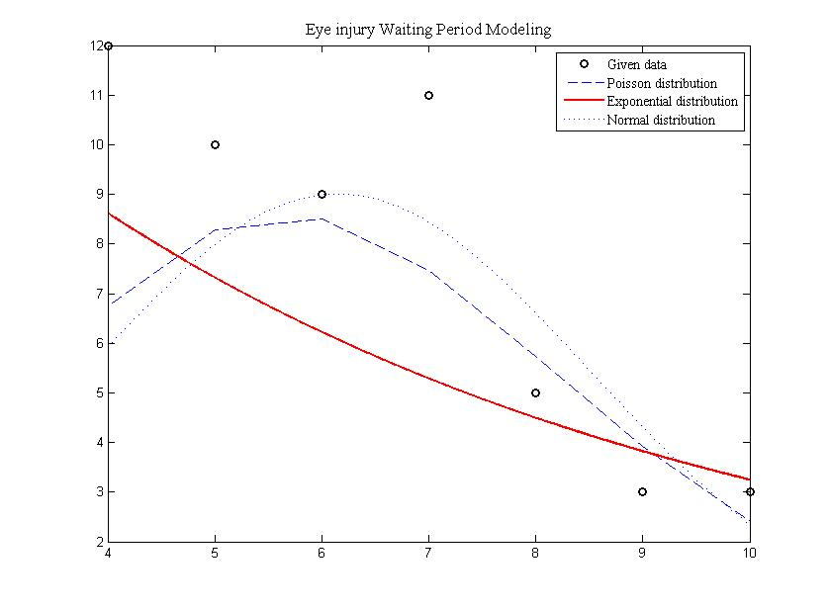 | Figure 3  Eye Injury Waiting Period Modeling
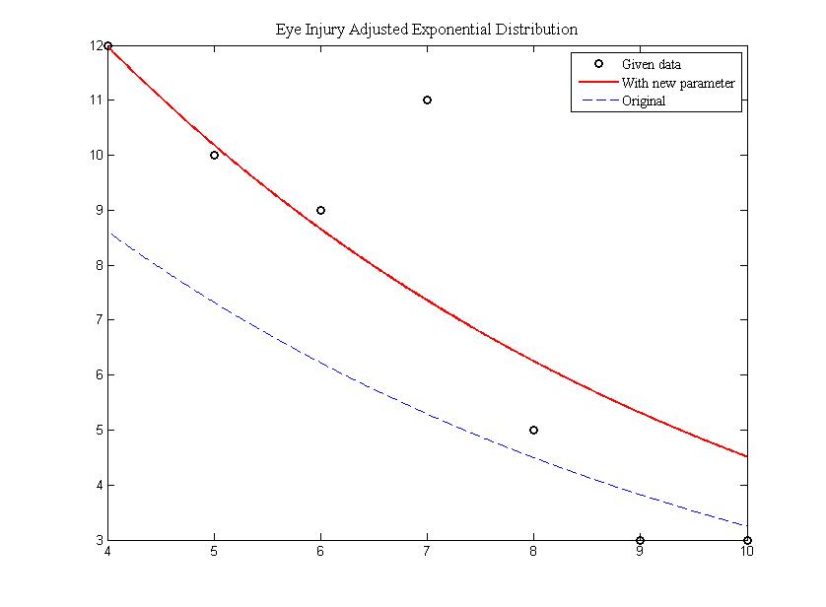 | Figure 4  Eye Injury Waiting Period Adjusted Exponential Distribution

  - For retina illness, T_{w} ~ normpdf ()
The normal distribution is adjusted by some parameter to fit the data (See figure 5). So we assume T_{w} = j+exppdf (), we tried different j from 0 to 3, using the least square method to get the smallest mean error. When j = 1.5, error = 8.0595, which is the minimum of all.
T_{w} = 1.5 + normpdf ()

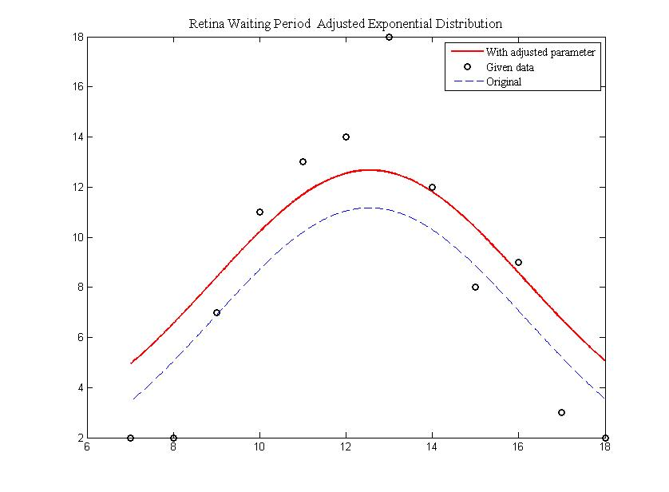 | Figure 5  Retina Waiting Period Adjusted Exponential Distribution

  - For glaucoma, T_{w} ~ normpdf (x,)
The same process with the retina case goes for the glaucoma case. We assume T_{w} = j+exppdf (), we tried different j from 0 to 3, using the least square method to get the smallest mean error. When j = 0.62, error = 6.5420, which is the minimum of all.
T_{w} = 0.62 + normpdf ()
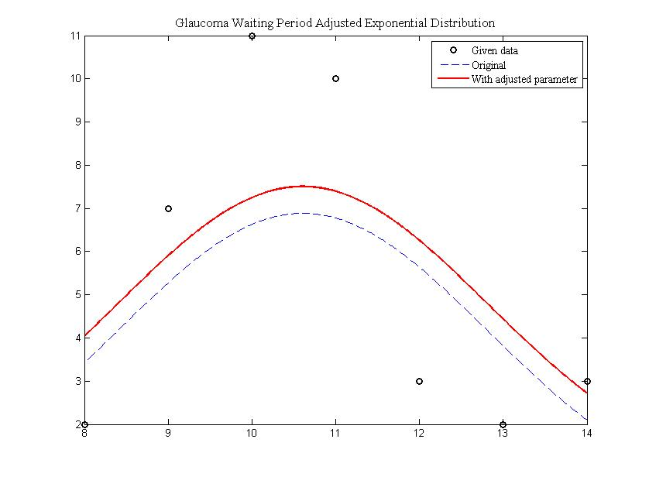 | Figure 6  Glaucoma Waiting Period Adjusted Exponential Distribution

- Simulation I: By model I, we can generate a random sequence of patients on a particular day.

- Simulation II: By model II, given the type of illness, we can generate the expected treatment period of the patient.

- Process simulation: Using simulation I and simulation II, we can get the matrix with each patient’s daily state, namely, diagnosed, under-treatment, or left. Also we can get another matrix containing each patient’s type of illness.

After we have completed the simulation of data, including both the types of patients and in-hospital periods of each patient, we are able to simulate the real situation of running a hospital.

The main idea of the program for process simulation is to let everything experience the day to day operation of running a hospital in reality with regard to the time line with the basic unit as one day. Then the daily life of a hospital is divided into the following parts: the diagnosis by doctors, getting the waiting list of patients for enrolment to the hospital by nurses, choice of patients for vacancies of beds on that day according to some rule by hospital manager, and the rejection of the extra Injury cases. After all these are done, other patients who are on the list should wait for the next day and the waiting list should be updated everyday. This kind of daily simulation then continues for a time period which should be large enough to ensure the statistics of the results reliable and meaningful.

The ultimate goal of this process simulation is to construct a status matrix, rows of which stand for the daily status of each single patient with regard to the time line of days, and columns of which stand for the status of all the patients in a same day. The status of patients can be represented by numbers as follows:
Numbers | Status
0 | Before the diagnosis or after the checkout
1 | On the waiting list
2 | In hospital

This matrix is quite similar to all the files in the archive room for patient management of every hospital which record some important characteristics of every patient.

The dimension of this status matrix can be quite large since we decide to simulate a time period of 1,000 days. With the previous data simulation, the approximate number of patients in 1,000 days is nearly 9,000. Therefore, we assign the status matrix to be 10,000 by 1,000.

On the basis of this status matrix, we can obtain every piece of information we desire, no matter small or large, including the following important variables:

- sequence of numbers of patients on the daily waiting list
- average daily change of numbers of patients on the waiting list
- average waiting time of each patient
- standard deviation of waiting time of each patient
- average in-hospital time of each patient
- rejection rate of emergency injury case
- weight assigned to waiting time and increasing speed in the evaluation of system

Here one important thing to note is that the rejection of injury case happens between the enrolment according to priority and the update of waiting list, and the exact value serves as one of the essential and effective indicator of the evaluation of the system.

- Problems Solutions

- Problem I: Evaluation standards

- Evaluation standards
We will compute a complex score according to different index for a priority rule, according to which a hospital rank the patients on the waiting list.

Related variables and their valid intervals are listed below:
v = the increasing speed of number of people on the waiting list
= average waiting time per person,
= standard deviation of waiting time per person,
= average treatment time per person,
p_{r} = proportion of rejections for eye injury patient, p_{r}
p_{t}-waiting = weight of consideration of waiting time
FCFS = consideration rate of the principle of first-come-first-serve,

Hence, the score becomes a function of these variables, namely
y = f(v, , , , n_{r}, FCFS)
To make it easy to evaluate, we want the score to be proportional to the effectiveness of the system. We can find that each of the above variables is inversely proportional to the effectiveness. Therefore we get the formula
max_{t-waiting} = the max waiting time a patient can bear100
max_{t-treatment} = the max treatment time for a patient18
r = rejection rate5%
As the priority rules become effective, each of the above term will tend to 1 and therefore y will tend to 100. Note that as some variable gets large enough, it is possible that some of the terms will become less than 0, which will reduce the score reasonably.

- FCFS Model Evaluation
Evaluation score: 76.6123
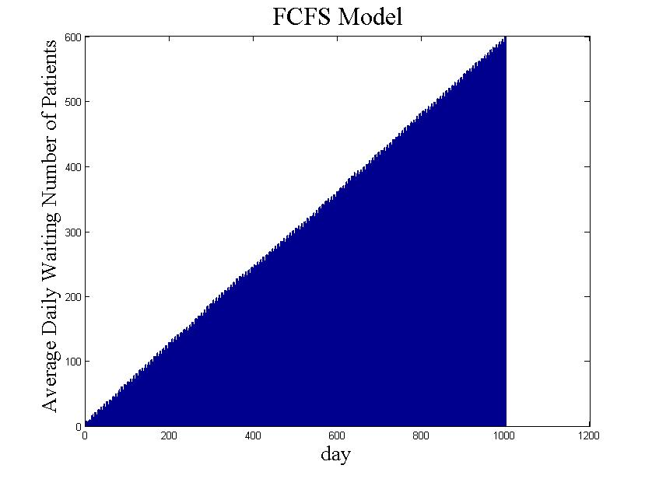 | Figure 7  Average Daily Number of Waiting Patients in FCFS Model

- Problem II: Suggested Models

Model A Illness-type Priority Model (ITP Model)

  - Priority Rule
We construct a score-evaluation system so that the higher the score of a patient, the prior he will be on the waiting list, basically according to the priority of different illness type.
    - The eye injury patient will always have the first priority.
    - If the day is Thursday to Saturday, double-eye cataract patient will get some priority comparative to other 2 types.
    - If the day is Saturday to Tuesday, single-eye cataract patient will get some priority comparative to other 2 types.
    - All the patients remaining on the waiting list will get corresponding priority according to their waiting period.
    - For the remaining patients, illness type with shorter in-hospital period will get the priority.

  - Evaluation
Evaluation score: 81.9610
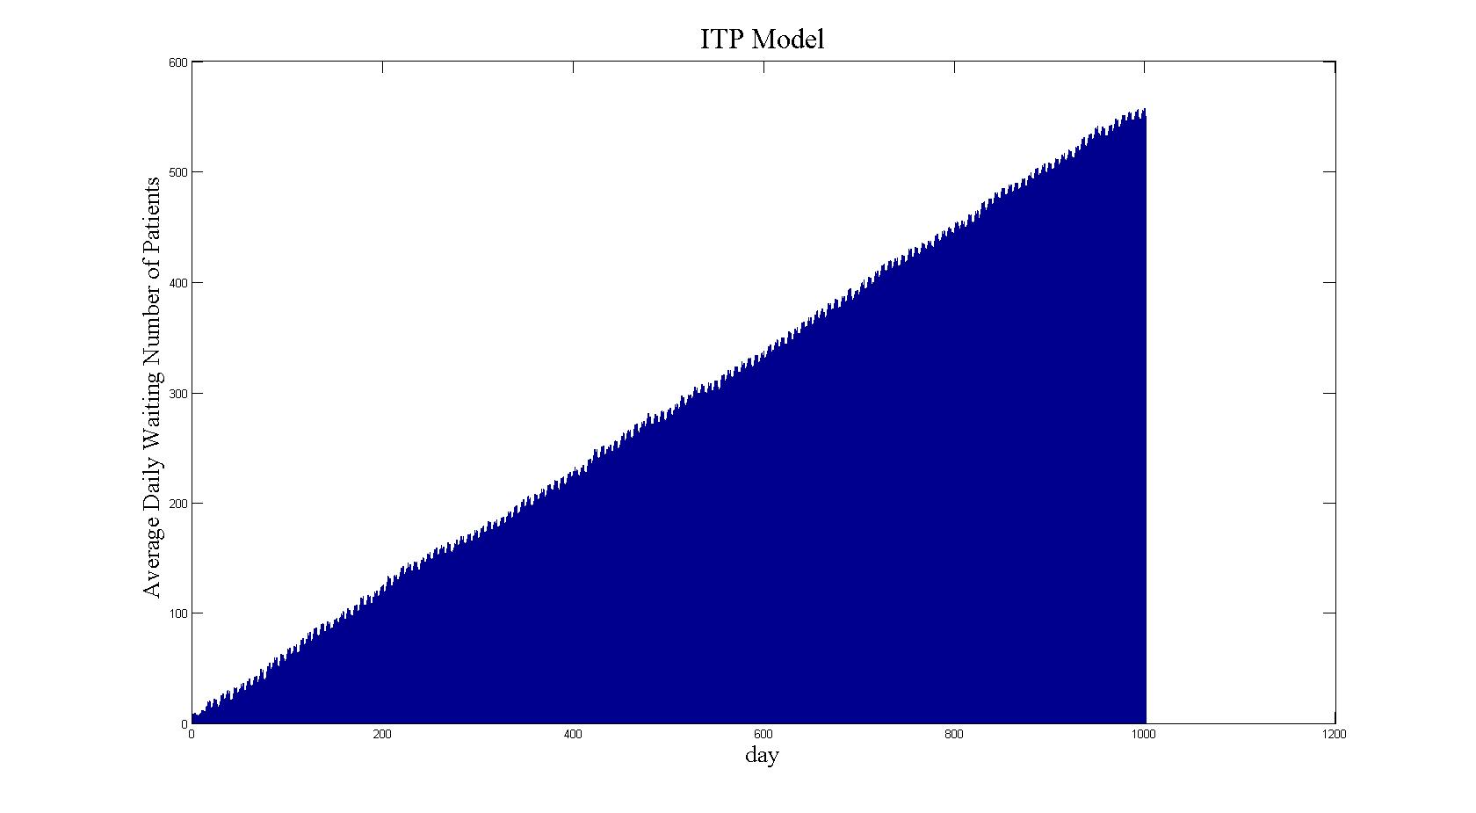 | Figure 8  Average Daily Number of Waiting Patients in ITP Model

Model B Excessive-time Model (ET Model)

  - Priority Rule
Patients with a higher excessive time T(w) will get priority.
T(w)=T(m)-T(n);
T(m):The period between the operation day and the day that the patient enters the hospital
T(n):the necessary period required for the preparation of the operation
Sheet 4 T(n) value for each type of illness
Illness Type | T(n) | The exclusive operation day | Theoretical optimized check-in day
Cataract(single eye) | 1 day | Monday or Wednesday | Sunday, Tuesday
Cataract(double eye) | 1 day | Monday and Wednesday | Sunday
Injury | 1 day | Every day | Every day
Retina | 58.3%  2 days | Tuesday, Thursday, Friday, Saturday and Sunday | Tuesday, Wednesday,  Thursday, Friday, Sunday
Retina | 41.7%  3 days | Tuesday, Thursday, Friday, Saturday and Sunday | Monday, Tuesday, Wednesday,  Thursday,  Saturday
Glaucoma | 63.4% patients:2 days | Tuesday, Thursday, Friday, Saturday and Sunday | Tuesday, Wednesday,  Thursday, Friday, and Sunday
Glaucoma | 36.6% patients:3 days | Tuesday, Thursday, Friday, Saturday and Sunday | Monday, Tuesday, Wednesday,  Thursday,  Saturday
Sheet 5 T(w) values for each situation with operations on weekends
Type / Day | 1 | 2 | 3 | 4 | 5 | 6 | 7
Cataract (double eye) | 6 | 5 | 4 | 3 | 2 | 1 | 0
Cataract (single eye) | 1 | 0 | 4 | 3 | 2 | 1 | 0
Retina | 0.583 | 0 | 0 | 0 | 0.417 | 0.583 | 0.417
Glaucoma | 0.634 | 0 | 0 | 0 | 0.366 | 0.634 | 0.366

  - Evaluation
Evaluation score: 70.1583
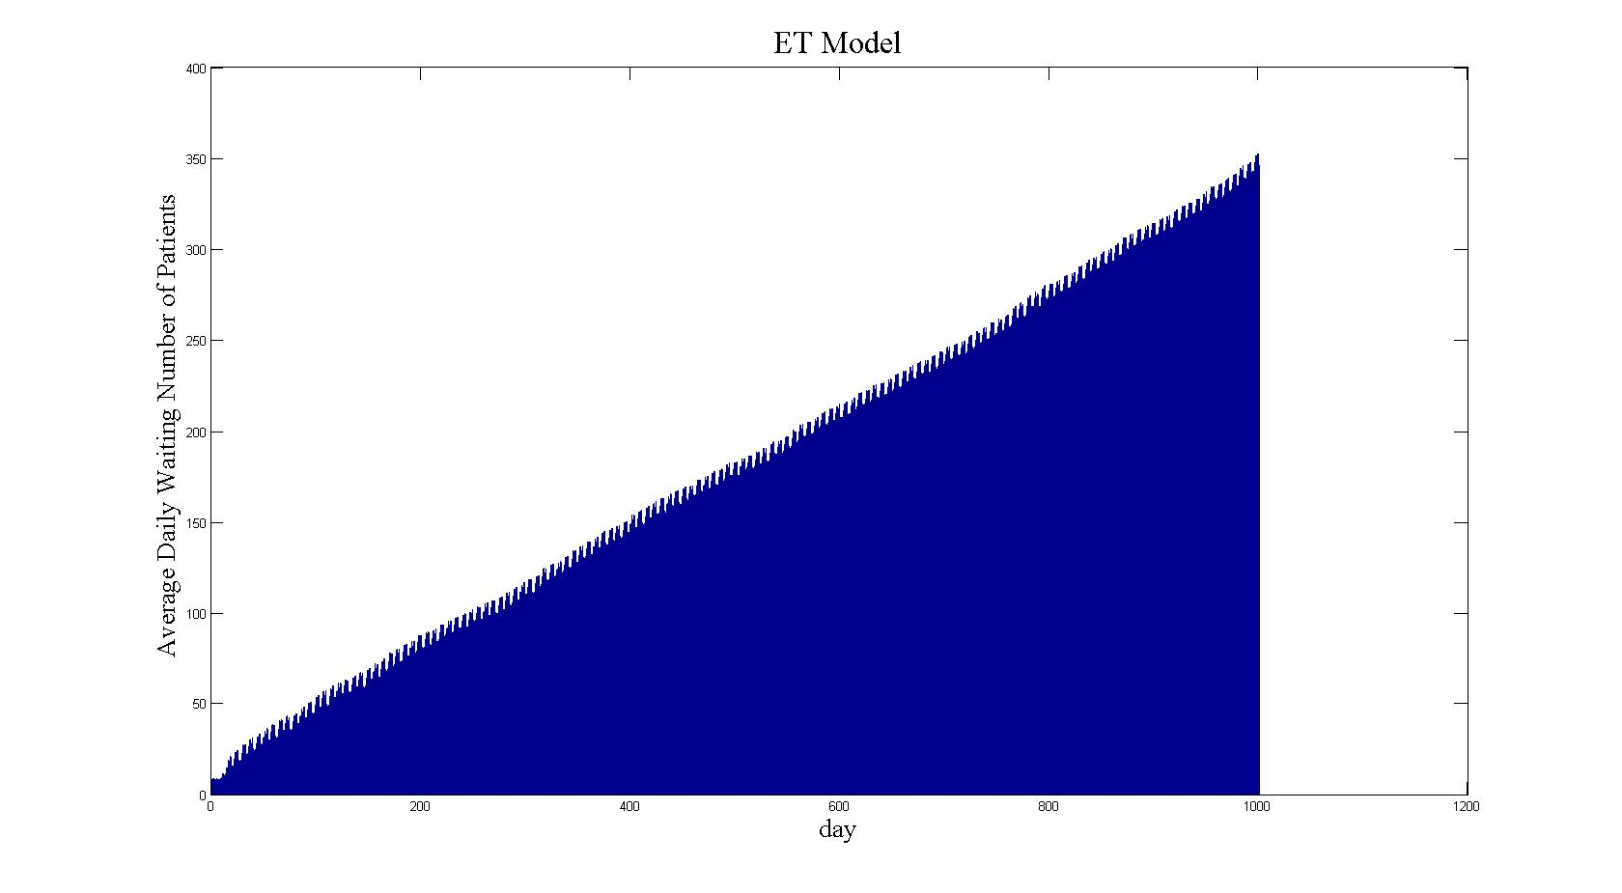 | Figure 9  Average Daily Number of Waiting Patients in ET Model

  - Explanation
If T (w)>0, meaning that the patient doesn’t check in on the theoretical optimized day, the bed occupation cost for the current patient will be increased due to the excessive in-hospital period. However, experiments indicate that T (w)>0 is favorable for the whole system because the date of check-out will not be changed because the operation day is not changed.
Waiting time | Operation Preparation time | Operation recovery time

Waiting time | Operation Preparation time | Operation recovery time

The decrease of waiting time will shorten the waiting list hence reduce the waiting time of other waiting patients.

- Problem III
According the entering date of current patients in the hospital, the expected leaving hospital date of the patients can be calculated by the in-hospital period simulation functions. Based on the expected number of patients leaving hospital on a certain day, the patients on the list will be assigned into the hospital on First-Come-First-Served principle. The whole process can be done with some modifications on the matlab programs used in Question 1.
We simulate hundred of times and take the mean value as a result.
The results are below:

1 | Double-eye Cataract | 2008-8-30 | 12-Sep | / | / | /
2 | Retina Illness | 2008-8-30 | 12-Sep | / | / | /
3 | Glaucoma | 2008-8-30 | 12-Sep | / | / | /
4 | Retina Illness | 2008-8-30 | 12-Sep | / | / | /
5 | Retina Illness | 2008-8-30 | 12-Sep | / | / | /
6 | Double-eye Cataract | 2008-8-30 | 13-Sep | / | / | /
7 | Single-eye Cataract | 2008-8-31 | 13-Sep | / | / | /
8 | Glaucoma | 2008-8-31 | 13-Sep | / | / | /
9 | Double-eye Cataract | 2008-8-31 | 13-Sep | / | / | /
10 | Retina Illness | 2008-8-31 | 13-Sep | / | / | /
11 | Retina Illness | 2008-8-31 | 14-Sep | / | / | /
12 | Retina Illness | 2008-8-31 | 14-Sep | / | / | /
13 | Glaucoma | 2008-8-31 | 14-Sep | / | / | /
14 | Single-eye Cataract | 2008-8-31 | 15-Sep | / | / | /
15 | Retina Illness | 2008-9-1 | 15-Sep | / | / | /
16 | Retina Illness | 2008-9-1 | 15-Sep | / | / | /
17 | Glaucoma | 2008-9-1 | 15-Sep | / | / | /
18 | Double-eye Cataract | 2008-9-1 | 15-Sep | / | / | /
19 | Double-eye Cataract | 2008-9-1 | 15-Sep | / | / | /
20 | Double-eye Cataract | 2008-9-1 | 15-Sep | / | / | /
21 | Retina Illness | 2008-9-1 | 15-Sep | / | / | /
22 | Single-eye Cataract | 2008-9-1 | 16-Sep | / | / | /
23 | Retina Illness | 2008-9-1 | 16-Sep | / | / | /
24 | Retina Illness | 2008-9-1 | 16-Sep | / | / | /
25 | Single-eye Cataract | 2008-9-2 | 16-Sep | / | / | /
26 | Single-eye Cataract | 2008-9-2 | 16-Sep | / | / | /
27 | Double-eye Cataract | 2008-9-2 | 16-Sep | / | / | /
28 | Single-eye Cataract | 2008-9-2 | 16-Sep | / | / | /
29 | Retina Illness | 2008-9-2 | 16-Sep | / | / | /
30 | Retina Illness | 2008-9-3 | 16-Sep | / | / | /
31 | Retina Illness | 2008-9-3 | 17-Sep | / | / | /
32 | Double-eye Cataract | 2008-9-3 | 17-Sep | / | / | /
33 | Single-eye Cataract | 2008-9-3 | 17-Sep | / | / | /
34 | Retina Illness | 2008-9-3 | 17-Sep | / | / | /
35 | Single-eye Cataract | 2008-9-3 | 17-Sep | / | / | /
36 | Retina Illness | 2008-9-3 | 17-Sep | / | / | /
37 | Retina Illness | 2008-9-3 | 17-Sep | / | / | /
38 | Double-eye Cataract | 2008-9-4 | 17-Sep | / | / | /
39 | Single-eye Cataract | 2008-9-4 | 17-Sep | / | / | /
40 | Glaucoma | 2008-9-4 | 17-Sep | / | / | /
41 | Retina Illness | 2008-9-4 | 18-Sep | / | / | /
42 | Retina Illness | 2008-9-4 | 18-Sep | / | / | /
43 | Retina Illness | 2008-9-4 | 18-Sep | / | / | /
44 | Glaucoma | 2008-9-4 | 18-Sep | / | / | /
45 | Double-eye Cataract | 2008-9-4 | 18-Sep | / | / | /
46 | Double-eye Cataract | 2008-9-4 | 18-Sep | / | / | /
47 | Glaucoma | 2008-9-4 | 18-Sep | / | / | /
48 | Glaucoma | 2008-9-4 | 18-Sep | / | / | /
49 | Retina Illness | 2008-9-4 | 18-Sep | / | / | /
50 | Retina Illness | 2008-9-4 | 18-Sep | / | / | /
51 | Double-eye Cataract | 2008-9-5 | 18-Sep | / | / | /
52 | Double-eye Cataract | 2008-9-5 | 19-Sep | / | / | /
53 | Double-eye Cataract | 2008-9-5 | 19-Sep | / | / | /
54 | Retina Illness | 2008-9-5 | 19-Sep | / | / | /
55 | Double-eye Cataract | 2008-9-5 | 19-Sep | / | / | /
56 | Glaucoma | 2008-9-5 | 19-Sep | / | / | /
57 | Double-eye Cataract | 2008-9-5 | 19-Sep | / | / | /
58 | Single-eye Cataract | 2008-9-5 | 20-Sep | / | / | /
59 | Double-eye Cataract | 2008-9-5 | 20-Sep | / | / | /
60 | Double-eye Cataract | 2008-9-5 | 20-Sep | / | / | /
61 | Double-eye Cataract | 2008-9-6 | 20-Sep | / | / | /
62 | Retina Illness | 2008-9-6 | 20-Sep | / | / | /
63 | Glaucoma | 2008-9-6 | 20-Sep | / | / | /
64 | Double-eye Cataract | 2008-9-6 | 20-Sep | / | / | /
65 | Retina Illness | 2008-9-7 | 20-Sep | / | / | /
66 | Double-eye Cataract | 2008-9-7 | 20-Sep | / | / | /
67 | Retina Illness | 2008-9-7 | 21-Sep | / | / | /
68 | Single-eye Cataract | 2008-9-8 | 21-Sep | / | / | /
69 | Retina Illness | 2008-9-8 | 21-Sep | / | / | /
70 | Retina Illness | 2008-9-8 | 21-Sep | / | / | /
71 | Single-eye Cataract | 2008-9-8 | 21-Sep | / | / | /
72 | Double-eye Cataract | 2008-9-8 | 21-Sep | / | / | /
73 | Single-eye Cataract | 2008-9-8 | 21-Sep | / | / | /
74 | Retina Illness | 2008-9-8 | 21-Sep | / | / | /
75 | Single-eye Cataract | 2008-9-8 | 21-Sep | / | / | /
76 | Glaucoma | 2008-9-9 | 22-Sep | / | / | /
77 | Glaucoma | 2008-9-9 | 22-Sep | / | / | /
78 | Retina Illness | 2008-9-9 | 22-Sep | / | / | /
79 | Single-eye Cataract | 2008-9-9 | 22-Sep | / | / | /
80 | Single-eye Cataract | 2008-9-9 | 22-Sep | / | / | /
81 | Retina Illness | 2008-9-10 | 22-Sep | / | / | /
82 | Single-eye Cataract | 2008-9-10 | 22-Sep | / | / | /
83 | Double-eye Cataract | 2008-9-10 | 22-Sep | / | / | /
84 | Single-eye Cataract | 2008-9-10 | 23-Sep | / | / | /
85 | Single-eye Cataract | 2008-9-10 | 23-Sep | / | / | /
86 | Double-eye Cataract | 2008-9-10 | 23-Sep | / | / | /
87 | Single-eye Cataract | 2008-9-10 | 23-Sep | / | / | /
88 | Glaucoma | 2008-9-10 | 23-Sep | / | / | /
89 | Double-eye Cataract | 2008-9-10 | 23-Sep | / | / | /
90 | Retina Illness | 2008-9-11 | 23-Sep | / | / | /
91 | Retina Illness | 2008-9-11 | 23-Sep | / | / | /
92 | Glaucoma | 2008-9-11 | 23-Sep | / | / | /
93 | Double-eye Cataract | 2008-9-11 | 23-Sep | / | / | /
94 | Double-eye Cataract | 2008-9-11 | 23-Sep | / | / | /
95 | Glaucoma | 2008-9-11 | 24-Sep | / | / | /
96 | Double-eye Cataract | 2008-9-11 | 24-Sep | / | / | /
97 | Eye Injury | 2008-9-11 | 12-Sep | / | / | /
98 | Double-eye Cataract | 2008-9-11 | 24-Sep | / | / | /
99 | Retina Illness | 2008-9-11 | 24-Sep | / | / | /
100 | Single-eye Cataract | 2008-9-11 | 24-Sep | / | / | /
101 | Retina Illness | 2008-9-11 | 24-Sep | / | / | /
102 | Retina Illness | 2008-9-11 | 24-Sep | / | / | /

- Problem IV: Excessive-time Model (ET Model)
  - Problem Analysis
Due to the arrangement of operations, the in-hospital period of a patient will be related to which day (from Monday to Sunday) he enters the hospital. In the original problem, Monday and Wednesday are only used for Cataract operations and the other five days are left for Retina and Glaucoma. Only the eye injury patients can take the operation at any time. From this point of view, apart from the ways of arranging beds for patients according to their arrival time and their expected treatment period, another kind of arrangement is mainly based on the excessive time between the actual and theoretical optimized check-in day.
  - Priority Rule
As given in Problem II.
  - Problem Solution and evaluation
If there is no operation on weekends, T (w) values will be changed accordingly:
- Monday – Wednesday Cataract Operation without operation on weekend
Sheet 6 T(w) values for Mon-Wed without operations on weekend
Type / Day | 7 | 6 | 5 | 4 | 3 | 2 | 1
Cataract (double eye) | 0 | 1 | 2 | 3 | 4 | 5 | 6
Cataract (single eye) | 0 | 1 | 2 | 3 | 4 | 0 | 1
Retina | 0.417 | 0.583 | 1.583 | 2.583 | 1.251 | 0 | 0.583
Glaucoma | 0.366 | 0.634 | 1.634 | 2.634 | 1.098 | 0 | 0.634
Evaluation score: 69.2692

In order to try the effectiveness of other arrangements, we tried the Tue-Thu case and the Wed-Fri case.
- Tuesday – Thursday Cataract Operation without operation on weekend
Sheet 7 T(w) values for Tue-Thu without operations on weekend
Type / Day | 7 | 6 | 5 | 4 | 3 | 2 | 1
Cataract(double eye) | 1 | 2 | 3 | 4 | 5 | 6 | 0
Cataract(single eye) | 1 | 2 | 3 | 4 | 0 | 1 | 0
Retina | 0.583 | 0.417 | 0.583 | 1.583 | 0.834 | 0.583 | 0.417
Glaucoma | 0.634 | 0.366 | 0.634 | 1.634 | 0.732 | 0.634 | 0.366
Evaluation score: 29.02

- Wednesday – Friday Cataract Operation without operation on weekend
Sheet 8 T(w) values for Wed-Fri without operations on weekend
Type / Day | 7 | 6 | 5 | 4 | 3 | 2 | 1
Cataract(double eye) | 2 | 3 | 4 | 5 | 6 | 0 | 1
Cataract(single eye) | 2 | 3 | 4 | 0 | 1 | 0 | 1
Retina | 0.417 | 0 | 0.583 | 1.583 | 2.583 | 1.251 | 0.583
Glaucoma | 0.366 | 0 | 0.634 | 1.634 | 2.634 | 1.098 | 0.634
Evaluation score: 29.54
  - Suggestion
The original Mon-Wed Cataract Arrangement is doing well under our evaluation system.

- Problem V: Fixed-proportion Bed Assignment Model
  - Problem Analysis
Setting a fixed-proportion bed assignment is a convenient way. A best proportion setting can minimize average in-hospital period T_{i} (T_{i} = T_{t} + T_{w}) for the system can be found.
  - Evaluation Rule
Some key variables concerned are:
T_{c} = average curing period for each illness type.
= The trend of T_{c} as time goes on.
r = the rejection rate for each illness type.
y = f (T_{c}, , r).
The trend of each type of illness will be stable after 50 days; therefore we take the interval [50, 300] for evaluation.
  - Problem solution
Basically, the number of beds prepared for each type of illness N_{b} is determined by two factors:
N_{k} – daily incidence for illness type k
T_{ck} – average check-in period for illness type k
Sheet 9 N_{b} values with N_{b}=f (N_{k} ,T_{ck})
Illness type | k | N_{k} | T_{ck}
Cataract(single eye) | 1 | 1.64 | 5.236
Cataract(double eye) | 2 | 2.18 | 8.56
Injury | 3 | 1.05 | 7.04
Retina | 4 | 1.033 | 10.487
Glaucoma | 5 | 2.787 | 12.54

The rough proportion of beds arranged for each disease can be calculated as follows,
, then we can get the result:
Sheet 10 Theoretical Proportion
Illness type | k | P_{k} | 79*P_{k} | Rounded
Cataract (single-eye) | 1 | 0.107 | 8.453 | 9
Cataract (double-eye) | 2 | 0.232 | 18.328 | 18
Injury | 3 | 0.092 | 7.268 | 7
Retina | 4 | 0.135 | 10.665 | 11
Glaucoma | 5 | 0.435 | 34.365 | 34

On the basis of the approximate proportion 9, 18, 7, 11 and 34, a simulation program is used to search for the optimal solution. We make an assumption that a patient of certain illness type can only enter the exclusive beds following the First-Come-First-Come principle.
(9, 18, 7, 11, 34) = 23.07

Other things constant, changing the number of beds assigned for eye injury patients gives:
N_{b} | 4 | 5 | 6 | 7 | 8 | 9
Average N_{b} | 1.1608 | 1.7912 | 2.5607 | 3.4157 | 4.345 | 5.3696
r | 0.2311 | 0.1331 | 0.0659 | 0.0332 | 0.0123 | 0.0047
We can conclude that as the rejection rate decreases, the utilization rate of beds also decreases. From another aspect, T_{c} of patients of each type of illness in [50, 300] is shown below:
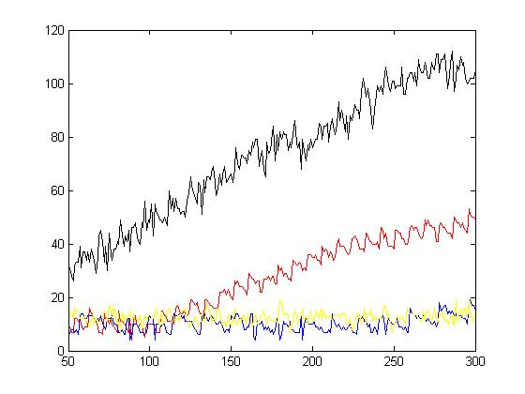  Black: Retina  Red: Cataract(single eye)  Yellow: Glaucoma  Blue: Cataract(double eye) | Figure 10  Curing period of patients of each type of illness in [50, 300]

The quota set for Retina patients and Cataract (single eye) is not sufficient.
Therefore we arrange the proportion around the original one to see T_{c,} and r.
Finally, we get the optimized proportion:
Sheet 11 Optimized Proportion
Illness type | Original | Adjustment | Optimized
Cataract (single-eye) | 9 | increase 2 => | 11
Cataract (double eye) | 18 | decrease 2 => | 16
Injury | 7 | change to => | 5
Retina | 11 | increase 5 => | 16
Glaucoma | 34 | decrease 3 => | 31

  - Evaluation
The new arrangement has T_{c} = 15.37, which is much smaller than the original plan. We simulate the situation with the optimized proportion for thousands of times and give 10 samples below. We can see that is quite stable and r = 0.1331 is acceptable.
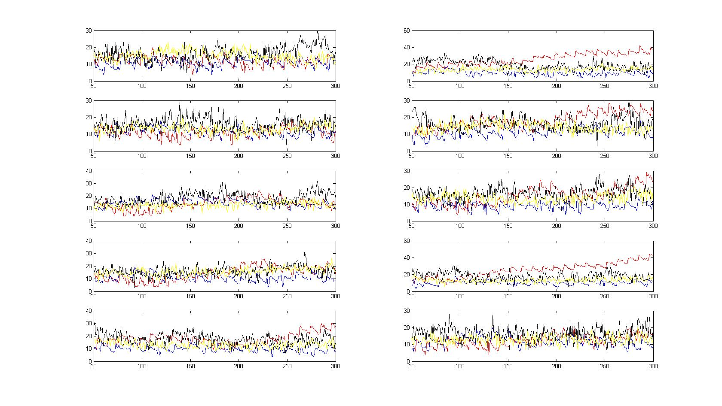 | Figure 10  Curing period of patients of each type of illness in[50, 300]

- Error Analysis
- During the simulation process of the number of patients every day and the in-hospital period of each patient
In all the five types of patients, Poisson distribution is used for the simulation of the number of patients every day. Different kinds of distributions including Poisson distribution, Normal Distribution and Exponential Distribution are used in simulation of the in-hospital period of each patient. In both simulations, the data provided in the problem do not exactly follow the theoretical distribution and some have a large deviation. This will lead to some error in the whole modeling process.

- In the Monte Carlo simulation program
Due to the computer capability and the software limitation, some simulation can only be processed for certain number of times. The MATLAB program in Problem II can only simulate the first 2000 days, which will affect the analysis of the long-term performance of the system.

- The difference between the model and the real life
Some important factors in real life, such as patients’ feelings, doctors’ capabilities and the fluctuation of patient numbers in different periods of a year are ignored in the modeling for this problem. These factors have to be taken into consideration for improvement of the reliability and accuracy of the model.

- Comparisons and Suggestions
- Comparison of the three models
We simulate thousands of times and take their mean value to plot the result.
FCFS Model | ITP Model | ET Model
Score: 53.4833 | 55.8405 | 70.1583
Max waiting number: 600 | 550 | 350

- Suggestions
  - According to the comparison of the three models, we find that the ET model is most effective among all. Therefore we recommend hospitals set the priority rule according to the excessive time.
  - If the hospital can offer an exclusive clinic for eye injury, say there is no “injury” priority, the daily waiting list will grow much slower than the one with “injury” priority.
ET Model | ET Model without the “injury” priority
 | 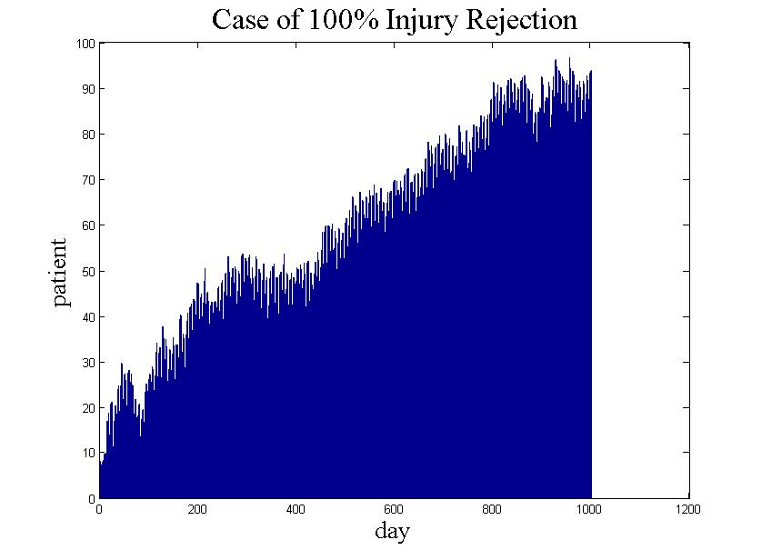
Max waiting number: 350 | 100

- Appendix
Tools used: MATLAB 7.6.0 (R2008a)
MATLAB Programs
(1) getStayPeriod(date,x)
% This is to give the number of days
% the patient will stay in the hospital

function y=getStayPeriod(date,x)
% x is the type of illness
% Generate a random number to compare with
% the standard value so that it can return
% the number of days the patient will stay in
% the hospital

% 1-cataract_single
% 2-cataract_double
% 3-injury
% 4-retina
% 5-glaucoma
y=0;
if x==1
y=getStayPeriodCataract(date,1);
elseif x==2
y=getStayPeriodCataract(date,2);
elseif x==3
[e sd]=getNormValue(x);
while y==0
y=round(1.39*exprnd(e-4));
end
elseif x==4
[e sd]=getNormValue(x);
while y==0
y = round(1.5+normrnd(e,sd));
end
else
[e sd]=getNormValue(x);
while y==0
y = round(0.62+normrnd(e,sd));
end
end

(2) getPatients()
% This is to give the number of patients coming to the hospital in a
% particular day and their type of illness.

function y=getPatients()
% This will give the user a matrix containing 1,2,3,4,5 representing the
% type of illness. The number of patients of each type aollow a poisson
% distribution according to the

% 1-cataract_single
% 2-cataract_double
% 3-injury
% 4-retina
% 5-glaucoma

x1=poissrnd(getPoissValue(1));
x2=poissrnd(getPoissValue(2));
x3=poissrnd(getPoissValue(3));
x4=poissrnd(getPoissValue(4));
x5=poissrnd(getPoissValue(5));

y1=ones(1,x1);
y2=2*ones(1,x2);
y3=3*ones(1,x3);
y4=4*ones(1,x4);
y5=5*ones(1,x5);

y=[y1 y2 y3 y4 y5];

(3) evaluate(n,k,beds,dayNum,weight)
% This is to calculate the score of the system according to the standard set by the assumption
function score=evaluate(n,k,beds,dayNum,weight)
record=zeros(n,1);

for i=1:n
[avgDailyWaitNum a b c d e f g]=multitest(beds,dayNum,weight);
record(i)=standard(a,b,c,d,e,f,g,k);
end
score=mean(record);

(4) multitest(beds,dayNum,weight)
% The main program to simulate the daily process of running a hospital

function [vector,increment,avgWait,stdWait,avgStay,totalReject,patientNumType3,weight]=multitest(beds,dayNum,weight)

patientNum=dayNum*10;
BedNum=zeros(dayNum,1);
Vacancy=beds*ones(dayNum,1);
TotalBefore=zeros(dayNum+1,1);
DailyNum=zeros(dayNum,1);
Status=zeros(patientNum,dayNum);
Type=zeros(patientNum,1);
Wait=zeros(patientNum,1);
Stay=zeros(patientNum,1);
DailyWaitNum=zeros(dayNum,1);
DailyReject=zeros(dayNum,1);

dailyPatient=0;
dailyIndex=0;
waitList=[];

for t=1:size(Status,2)
% Data Simulation
dailyPatient=getPatients();
DailyNum(t)=length(dailyPatient);
dailyIndex=(TotalBefore(t)+1):(TotalBefore(t)+DailyNum(t));
Type(dailyIndex)=dailyPatient;
BedNum(t)=sum(floor(Status(:,t)./2));
Vacancy(t)=beds-BedNum(t);

% Diagnosis
Status(dailyIndex,t)=1; % All diagnosed remain waiting
Wait(dailyIndex)=Wait(dailyIndex)+1;

% Get the waiting list
priority=zeros(length(waitList),1);
for i=1:length(waitList)
priority(i)=getPriorityFCFS(Type(waitList(i)),Wait(waitList(i)),t,weight);
end
enrolListIndex=[];
for i=1:min(length(waitList),Vacancy(t))
[y,index]=max(priority);
enrolListIndex(i)=index;
priority(enrolListIndex(i))=-100;
end
enrolList=waitList(enrolListIndex);
waitList(enrolListIndex)=0;
waitList=waitList(find(waitList~=0));
waitList=[enrolList waitList];

% Priority Enrolment
for i=1:min(length(waitList),Vacancy(t))
Wait(waitList(i))=sum(Status(waitList(i),1:t));
Stay(waitList(i))=getStayPeriod(t,Type(waitList(i)));
Status(waitList(i),t:(t+Stay(waitList(i))-1))=2;
end
waitList=waitList((Vacancy(t)+1):length(waitList));

% Injury Rejection
DailyReject(t)=length(find(Type(waitList)==3));
waitList=waitList(find(Type(waitList)~=3));

% Others wait
Status(waitList,t)=1;

% Data Update
waitList=[waitList dailyIndex];
DailyWaitNum(t)=length(waitList);
Wait(waitList)=Wait(waitList)+1;
TotalBefore(t+1)=TotalBefore(t)+DailyNum(t);
end

vector=DailyWaitNum;
increment=mean(vector(2:length(vector))-vector(1:(length(vector)-1)));
avgWait=mean(Wait);
stdWait=std(Wait);
avgStay=mean(Stay);
totalReject=sum(DailyReject);
patientNumType3=sum(length(find(Type==3)));

end

(5) iterate(trial,beds,dayNum,weight)
% This is to plot one of the most important index – the average daily number of waiting patients
function avgDailyWaitNum=iterate(trial,beds,dayNum,weight)

TotalDailyWaitNum=zeros(trial,dayNum);
for i=1:trial
[TotalDailyWaitNum(i,:),a,s,d,f,g,h,j]=multitest(beds,dayNum,weight);
end
avgDailyWaitNum=mean(TotalDailyWaitNum);
bar(avgDailyWaitNum),title('Average Daily Waiting Number of Patients'),xlabel('day'),ylabel('patient');

(6) getPoissValue(x)
function e=getPoissValue(x)
% This is to return the expectation of the corresponding illness type

if x==1
A=0:5;
B=[9 24 15 7 5 1];
elseif x==2
A=0:7;
B=[6 19 13 12 6 3 1 1];
elseif x==3
A=0:3;
B=[21 20 16 4];
elseif x==4
A=0:7;
B=[2 16 11 11 9 10 1 1];
else
A=0:4;
B=[20 25 13 0 3];
end
e = dot(A,B)/sum(B);

(7) probf(h1,h2,h3,h4,h5)
% This is a program about problem V

function y=probf(h1,h2,h3,h4,h5)
tempa=0;
tempb=0;
tempavg=0;
for i=1:100
j=0;
bednuma=zeros(1000,1);
patienta=zeros(10000,3);
bednuma(1)=h1;

bednumb=zeros(1000,1);
patientb=zeros(10000,3);
bednumb(1)=h2;

bednumc=zeros(1000,1);
patientc=zeros(10000,3);
bednumc(1)=h3;

bednumd=zeros(1000,1);
patientd=zeros(10000,3);
bednumd(1)=h4;

bednume=zeros(1000,1);
bednume(1)=h5;
patiente=zeros(10000,3);
j1=0;
j2=0;
j3=0;
j4=0;
j5=0;
cresist=0;
for i=1:400
a(i)=poissrnd(1.64);
b(i)=poissrnd(2.18);
c(i)=poissrnd(1.05);
d(i)=poissrnd(1.033);
e(i)=poissrnd(2.787);
for k=(j1+1):(j1+a(i))
patienta(k,1)=i;
end
for k=(j2+1):(j2+b(i))
patientb(k,1)=i;
end
for k=(j3+1):(j3+c(i))
patientc(k,1)=i;
end
for k=(j4+1):(j4+d(i))
patientd(k,1)=i;
end
for k=(j5+1):(j5+e(i))
patiente(k,1)=i;
end
if i>1
bednuma(i)=bednuma(i-1);
for k=1:j1
if patienta(k,3)==i
bednuma(i)=bednuma(i)+1;
end
end
bednumb(i)=bednumb(i-1);
for k=1:j2
if patientb(k,3)==i
bednumb(i)=bednumb(i)+1;
end
end
bednumc(i)=bednumc(i-1);
for k=1:j3
if patientc(k,3)==i
bednumc(i)=bednumc(i)+1;
end
end
bednumd(i)=bednumd(i-1);
for k=1:j4
if patientd(k,3)==i
bednumd(i)=bednumd(i)+1;
end
end
bednume(i)=bednume(i-1);
for k=1:j5
if patiente(k,3)==i
bednume(i)=bednume(i)+1;
end
end
end
if j1>0
for k=1:j1
if bednuma(i)>0
if (patienta(k,1)~=0)&(patienta(k,2)==0)
patienta(k,2)=i;
patienta(k,3)=i+getStayPeriod(i,1);
bednuma(i)=bednuma(i)-1;
end
end
end
end
if j2>0
for k=1:j2
if bednumb(i)>0
if (patientb(k,1)~=0)&(patientb(k,2)==0)
patientb(k,2)=i;
patientb(k,3)=i+getStayPeriod(i,2);
bednumb(i)=bednumb(i)-1;
end
end
end
end
if j4>0
for k=1:j4
if bednumd(i)>0
if (patientd(k,1)~=0)&(patientd(k,2)==0)
patientd(k,2)=i;
patientd(k,3)=i+getStayPeriod(i,4);
bednumd(i)=bednumd(i)-1;
end
end
end
end
if j5>0
for k=1:j5
if bednume(i)>0
if (patiente(k,1)~=0)&(patiente(k,2)==0)
patiente(k,2)=i;
patiente(k,3)=i+getStayPeriod(i,5);
bednume(i)=bednume(i)-1;
end
end
end
end
if j3>0
for k=(j3-c(i-1)+1):j3
if (patientc(k,1)~=0)&(patientc(k,2)==0)
if bednumc(i)>0
patientc(k,2)=i;
patientc(k,3)=i+getStayPeriod(i,3);
bednumc(i)=bednumc(i)-1;
else
patientc(k,2)=-1;
patientc(k,3)=patientc(k,1);
cresist=cresist+1;
end
end
end
end
j1=j1+a(i);
j2=j2+b(i);
j3=j3+c(i);
j4=j4+d(i);
j5=j5+e(i);
end
%patientc(1:1000,:)
%bednume(1:500)
%m=[1:1000];
%tempa=tempa+sum(bednumc(50:300))/250;
%plot(m,bednumc(1:1000))
resistrate=cresist/(j3-c(i));
%tempb=tempb+resistrate;
%x=[101:1:500];
%plot(x,patienta(x,3)-patienta(x,1),'r');
%hold on;
%plot(x,patientb(x,3)-patientb(x,1),'b');
%hold on;
%plot(x,patientd(x,3)-patientd(x,1),'k');
%hold on;
%plot(x,patiente(x,3)-patiente(x,1),'y');
sums1=sum(patienta((sum(a(1:50))+1):(sum(a(1:300))),3)-patienta((sum(a(1:50))+1):(sum(a(1:300))),1))+sum(patientb((sum(b(1:50))+1):(sum(b(1:300))),3)-patientb((sum(b(1:50))+1):(sum(b(1:300))),1))+sum(patientd((sum(d(1:50))+1):(sum(d(1:300))),3)-patientd((sum(d(1:50))+1):(sum(d(1:300))),1))+sum(patiente((sum(e(1:50))+1):(sum(e(1:300))),3)-patiente((sum(e(1:50))+1):(sum(e(1:300))),1));
sums2=sum(patientc((sum(c(1:50))+1):(sum(c(1:300))),3)-patientc((sum(c(1:50))+1):(sum(c(1:300))),1));
sums=sums1+sums2;
nums=sum(a(51:300))+sum(b(51:300))+sum(c(51:300))*(1-resistrate)+sum(d(51:300))+sum(e(51:300));
avg=sums/nums;
tempavg=tempavg+avg;
end
%tempa/30
%tempb/30
y=tempavg/100;

(8) Priority Rule for FCFS Model
function y=getPriorityFCFS(type,waitTime,t,weight)
if type==3
y=1000+waitTime;
else
y=waitTime;
end

(9) Priority Rule for ITP Model
function y=getPriorityITP(type, waitingDays, date, weight)
% Input: Index-the index of the patient
% date
% A-matrix of the patient schedule
% Output: Priority - a complex score of a particular patient
% The higher the score, the higher the priority

% 1-cataract_single
% 2-cataract_double
% 3-injury
% 4-retina
% 5-glaucoma

% Different average treatmentDays according to different illness type
treatmentDays=zeros(1,5);
treatmentDays(1)=getNormValueCataract(1);
treatmentDays(2)=getNormValueCataract(2);
[treatmentDays(3), sd]=getNormValue(3);
[treatmentDays(4), sd]=getNormValue(4);
[treatmentDays(5), sd]=getNormValue(5);

y=0;
y=y+(waitingDays/treatmentDays(type))*weight; % Use the avg treatmentDays for each type
% Injury priority
if type==3
y=y+1000;
% cataract_single
elseif type==1
if rem(date,7)==0||rem(date,7)==1||rem(date,7)==2
y=y+1;
end
% cataract_double
elseif type==2
if rem(date,7)==5||rem(date,7)==6||rem(date,7)==0
y=y+2;
end
else
end

(10) Priority Rule for ET Modl
function y=getPriorityET(type, waitingTime, date, weight)
% Input: Index-the index of the patient
% date
% A-matrix of the patient schedule
% Output: Priority - a complex score of a particular patient
% The higher the score, the higher the priority

% 1-cataract_single
% 2-cataract_double
% 3-injury
% 4-retina
% 5-glaucoma

% Different average treatmentDays according to different illness type
treatmentDays=zeros(1,5);
treatmentDays(1)=2.9;
treatmentDays(2)=4.96;
treatmentDays(3)=7.04;
treatmentDays(4)=8.08;
treatmentDays(5)=10.17;

% Different wasting time for different illness type and day
wastingTime=zeros(5,7);
for i=1:5
wastingTime(1,i)=i-1;
end
wastingTime(1,7)=1;
for i=1:7;
wastingTime(2,i)=i-1;
end
wastingTime(4,1)=0.366;
wastingTime(4,2)=0.634;
wastingTime(4,3)=0.366;
wastingTime(4,7)=0.634;
wastingTime(5,1)=0.417;
wastingTime(5,2)=0.583;
wastingTime(5,3)=0.417;
wastingTime(4,1)=0.583;

% Convert date to day
if rem(date,7)==1
day=7;
elseif rem(date,7)==0
day=6;
else
day=rem(date,7)-1;
end

y=1000;
y=wastingTime(type, day); % Use the avg treatmentDays for each type
% Injury priority
if type==3
y=y+1000;
end

------ END ------

